MINISTRY OF EDUCATION AND SCIENCE OF UKRAINE

O. M. BЕКЕTОV NATIONAL UNIVERSITY
of URBAN ECONOMY in KHARKIV

METHODOLOGICAL GUIDELINES

for independent work
on the discipline

“EDUCATIONAL PRACTICE”

(for first-year full-time foreigner students first (bachelor's) level of higher education specialty 191 – Architecture and urban planning)

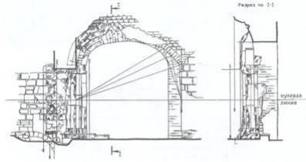

Kharkiv
O. M. Beketov NUUE
2021
Methodological guidelines for independent work on the discipline “Educational practice” (for first-year full-time foreigner students first (bachelor's) level of higher education specialty 191 – Architecture and urban planning) / O. M. Beketov National University of Urban Economy in Kharkiv ; com. : M. Votinov, S. Bronnikova. – Kharkiv : O. M. Beketov NUUE, 2021. – 30 p.

Compilers: M. Votinov,
S. Bronnikova

Reviewer PhD in Architectural sciences O. Smirnova

Recommended by the department of fundamentals of architectural design,
record № 1 від 29 серпня 2020 р.

